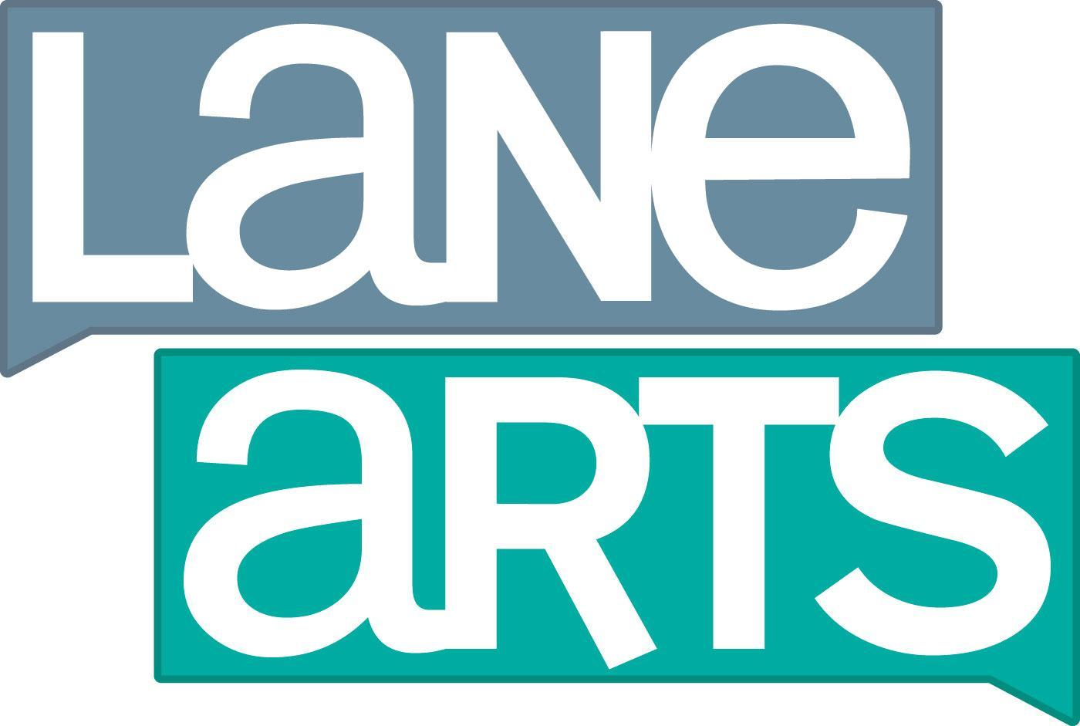
Lane Arts Council

Fiscal Sponsorship Information

174 East 16th Ave, Suite 125, Eugene, OR 97401 (541) 485-2278

www.lanearts.org

As a service to our community, Lane Arts Council (LAC) may serve as fiscal sponsor for arts projects that fit within LAC’s exempt purpose, mission and goals but are undertaken by other individuals or entities. LAC works to strengthen and support the arts throughout Lane County. LAC is an Oregon nonprofit corporation, which is recognized as exempt from taxation under IRC 501(c)(3).

Why is Fiscal Sponsorship Needed?
Many individuals or entities engage in arts projects without becoming tax-exempt nonprofit organizations. However, these projects often are not eligible to receive charitable gifts, grants or sponsorships. In addition, they may not have the infrastructure (e.g. people, bank accounts, bookkeeping, central mailing address, etc.) needed to be successful. As a fiscal sponsor, LAC can help with those challenges. Fiscal sponsorship is a legal arrangement through which LAC can accept tax-deductible contributions and other revenue to support arts projects pursued by individuals or entities that are not tax exempt.

How does it work?
Fiscal sponsorship is often done incorrectly, and LAC is committed to doing it properly to better serve the Lane County arts community. We use the widely accepted models of fiscal sponsorship described in Gregory Colvin’s book Fiscal Sponsorship: 6 Ways to Do it Right. Under these models, LAC typically provides fiscal sponsorships as follows.

- Individual Artists: LAC can often engage in “grantor-grantee” fiscal sponsorship for individuals. The individual applies to LAC for fiscal sponsorship for an arts project and LAC can conditionally agree to award the individual a grant if the project fits within LAC’s mission and goals. The individual does the work to solicit the funds which are received by LAC and then paid out to the individual as a grant when and if they are received. The individual then implements the project and provides a grant report back to LAC.

- Entities: Some arts groups are organized as nonprofits, trusts, limited liability companies or other entities under state law, but are not eligible for or have not applied for or been granted tax-exempt status by the IRS. The entity can run its programs, write its own checks, have its own board and employees, etc. but it can’t take charitable gifts or receive grants. In this case, LAC can often use the “grantor-grantee” model as described above. LAC can make a conditional grant approval, receive the funds that the entity solicits, and then pay them out to the entity as a grant. The entity then implements its project and provides grant reports back to LAC.

How much does it cost?
Fiscal sponsors usually charge a fee based on a percentage of total gross contributions received by the fiscal sponsor in order to cover administrative expenses. LAC charges a minimum of 10% of the total gross contributions received by LAC for the project depending on the complexity of the sponsorship. The percentage is decided upon before fiscal sponsorship begins and is included in the written sponsorship agreement. LAC does not pay for donation processing or vendor fees related to donation processing.

What is the process for fiscal sponsorship?
Individuals or entities interested in fiscal sponsorship should first contact LAC’s staff contact designated below. The process usually requires two months, sometimes more depending on the size and complexity of the request.

Non-Discrimination Policy
All projects must align with our non-discrimination policy:
Lane Arts Council is an equal opportunity employer and does not discriminate on the basis of race, religion, color, gender, sex, sexual preference, age, national origin, disability, veteran status, or any other classification by law.

For more information about fiscal sponsorship, please contact Stacey Ray, Executive Director, at (541) 485-2278 or stacey@lanearts.org.

Lane Arts Council

Fiscal Sponsorship Application

174 East 16th Ave, Suite 125, Eugene, OR 97401 (541) 485-2278

www.lanearts.org

Project:
Dates/Duration:
Amount Seeking to Raise:
Location:
Responsible Individual or Entity:
Address:
Phone number:
Email:

Please respond to the following questions:

- Please describe how your project fits within Lane Arts Council’s mission: to cultivate strong and creative arts communities in Lane County by providing high-quality arts experiences, engaging people of all ages in arts education, and encouraging artistic endeavors.

- Describe the history of your project. Are you aware of any similar projects in Lane County?

- For entity applicants, describe your organizational structure, including paid staff, board, advisory committee and/or volunteers. If you have paid staff, are they employees or contractors?

- Do you have a fiscal sponsor or have you ever had a fiscal sponsor?

- Why do you seek fiscal sponsorship?

- Please describe the communities or potential audiences who will benefit from the project.

- Explain your time frame for the project. How long will you require fiscal sponsorship?

- What sources and amounts of funding will you seek? Please include grantors and businesses you plan to approach.

- What will you do if you do not reach your fundraising goals for your project? Alternatively, what will you do with remaining funds once the project and fiscal sponsorship agreement are complete?

- Do you currently carry insurance for your project? If not, are you willing to purchase insurance for your project?

- Why type of professional development (trainings and workshops) do you or your organization seek?

Please attach supplemental materials including a project budget and resumes of core artists/individuals involved in the project.

Signed:

__________________________________
Responsible Individual

__________________________________
Date

